JULY, 2021

1. WEBINAR ON “DESIGN THINKING: FOSTERING INNOVATION IN YOUNG MIND” ORGANISED BY UDHAMPUR CAMPUS, UNIVERSITY OF JAMMU IN COLLOBORATION WITH UNIVERSITY BUSINESS INCUBATION AND INNOVATION CENTRE UNDER UDHAMPUR CAMPUS CAPACITY BUILDING SERIES (UCCBS)
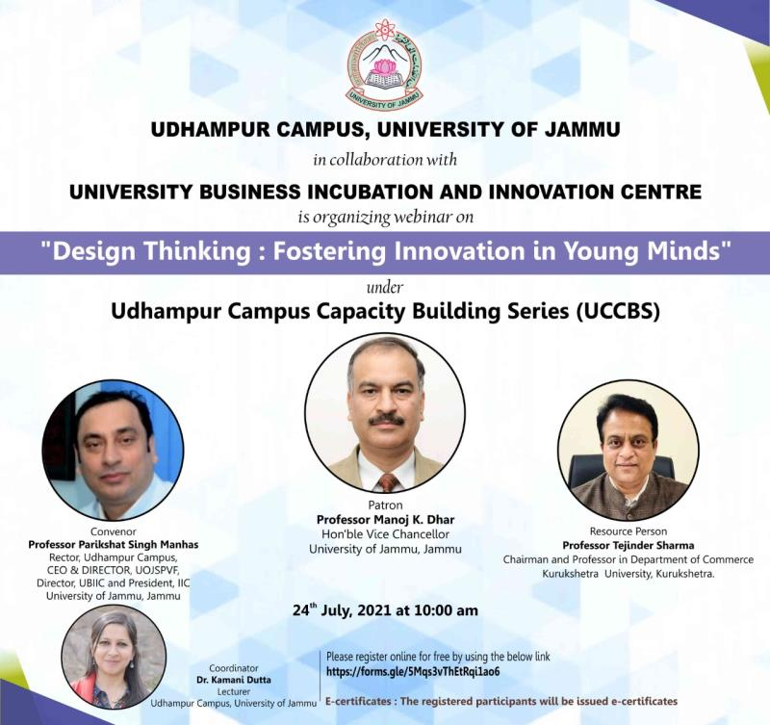

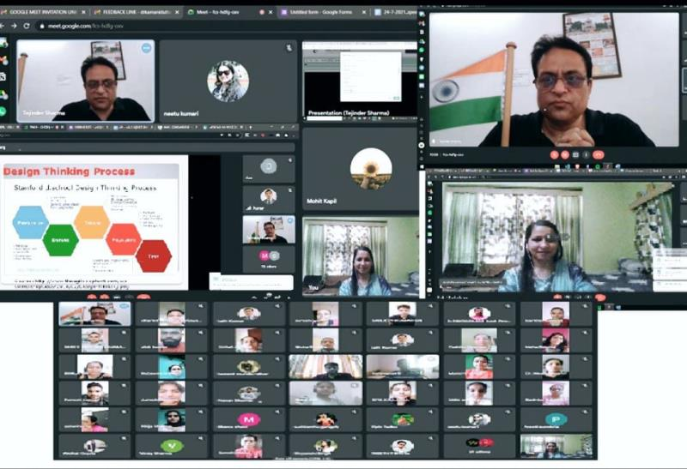

2. Webinar on Fiscal Policy Stance of India - 2021 and Skill Development in collaboration with University Of Jammu Special Purpose Vehicle Fund Under Udhampur Campus Capacity Building Series (UCCBS)

3. Webinar On Fiscal Policy Stance of India - 2021 And Skill Development In Collaboration With University Of Jammu Special Purpose Vehicle Fund Under Udhampur Campus Capacity Building Series (UCCBS).
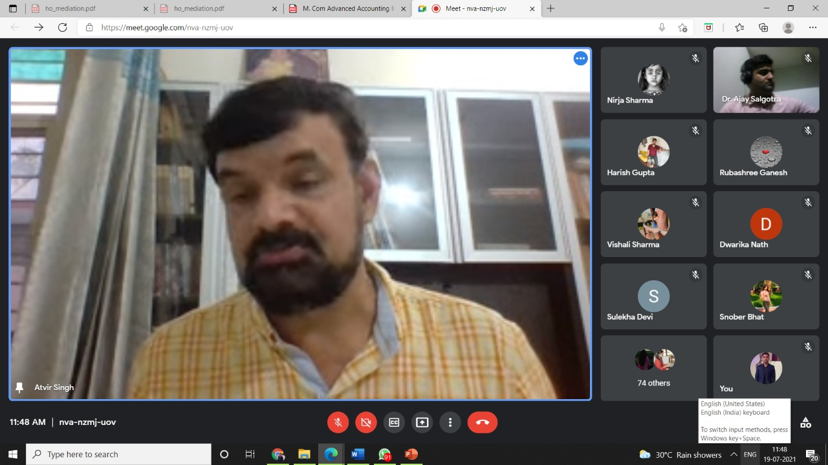
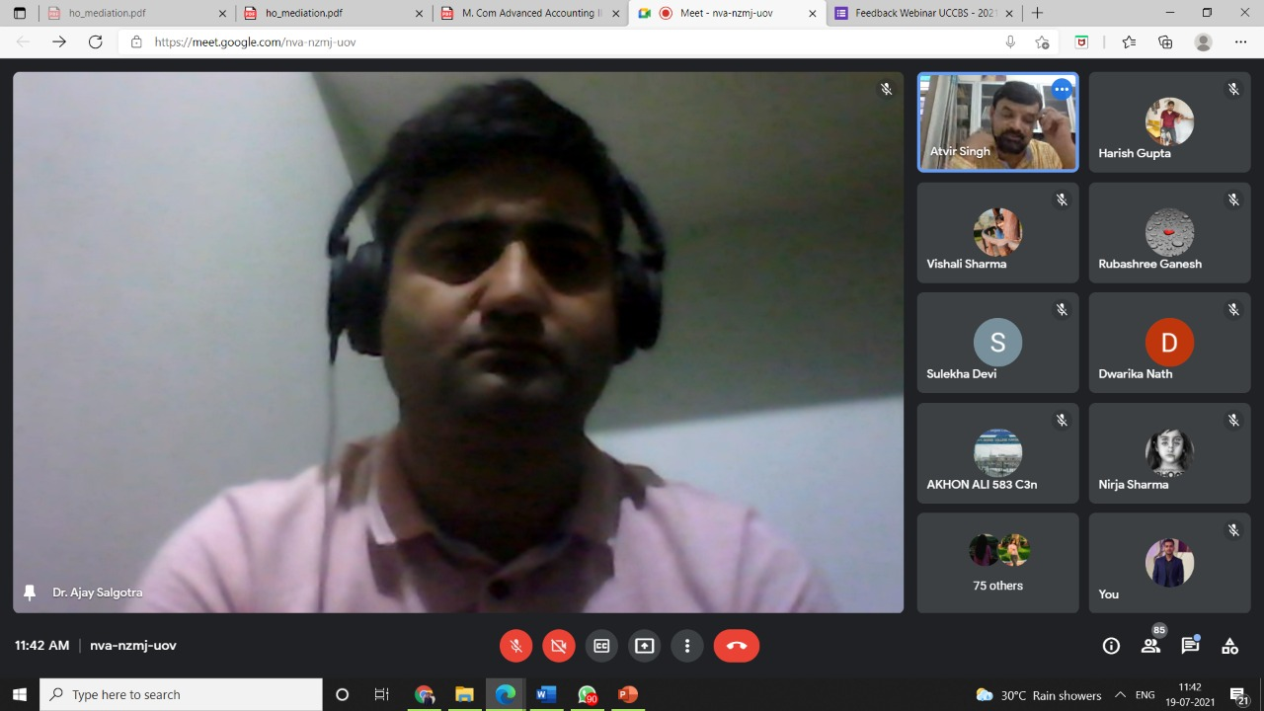

3. Webinar On Covid - 19 Pandemic: Challenging Crises For Managers In Business Organizations Organized By Udhampur Campus, University Of Jammu In Collaboration With University Of Jammu Special Purpose Vehicle Fund Under Udhampur Campus Capacity Building Series (UCCBS)

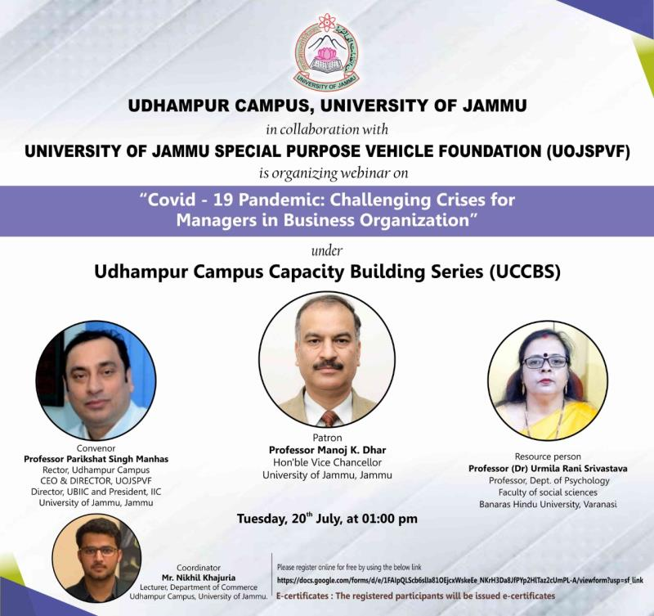
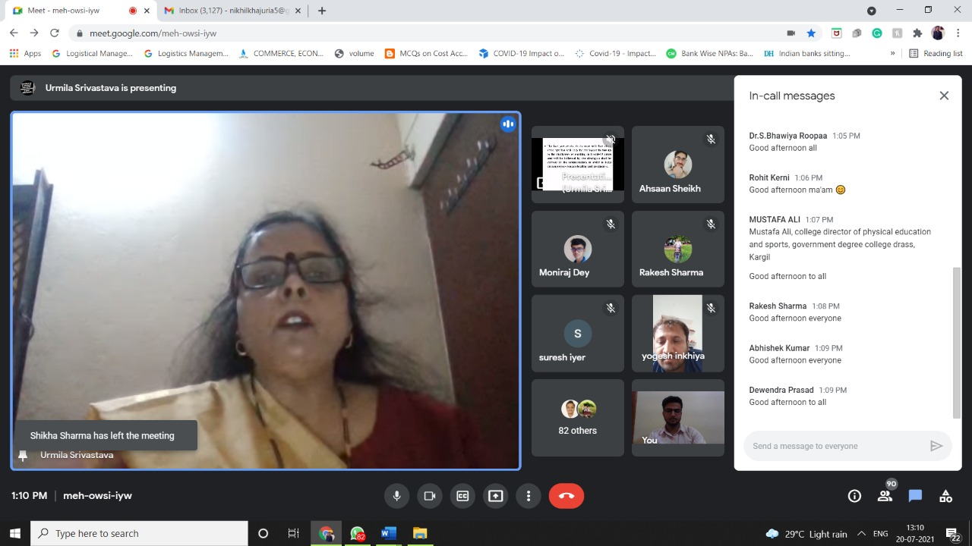

4. International Lecture Organized by Udhampur Campus, University Of Jammu In Collaboration With University Of Jammu Special Purpose Vehicle Fund Under Udhampur Campus Capacity Building Series (UCCBS)

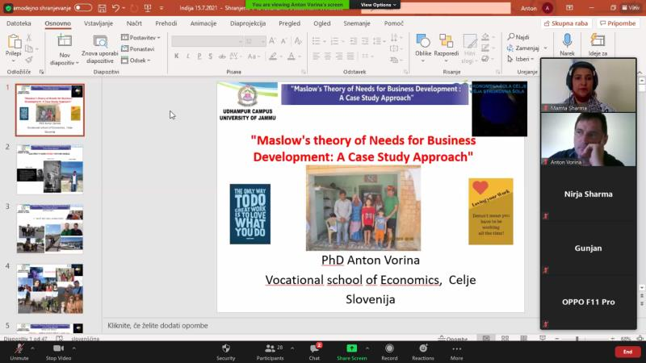

5. Webinar On Investment and Career Options In Capital Market In Collaboration With Central Depository Services Ltd. And Bombay Stock Exchange Under UCCBS
