FEBRUARY, 2021

1, Extension Lecture On Skill Development

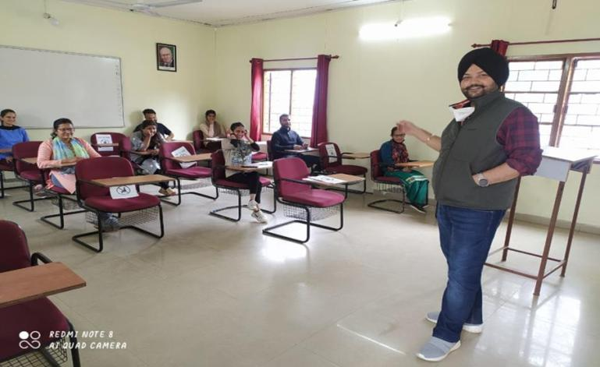

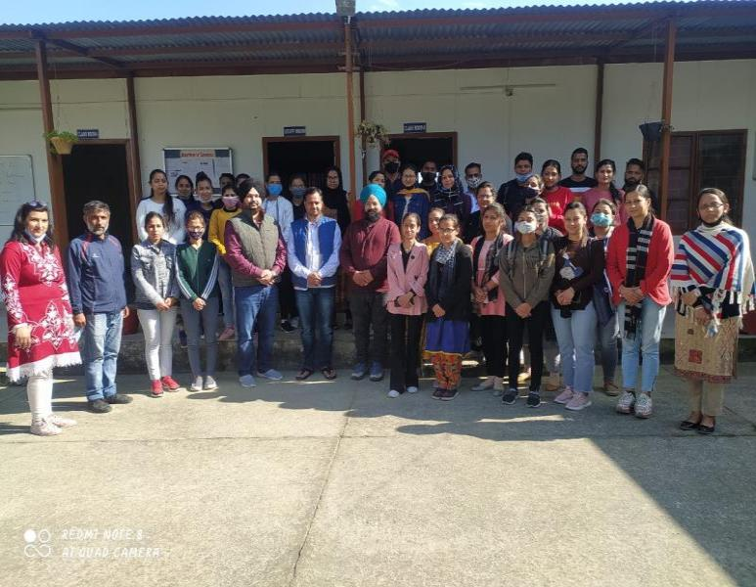

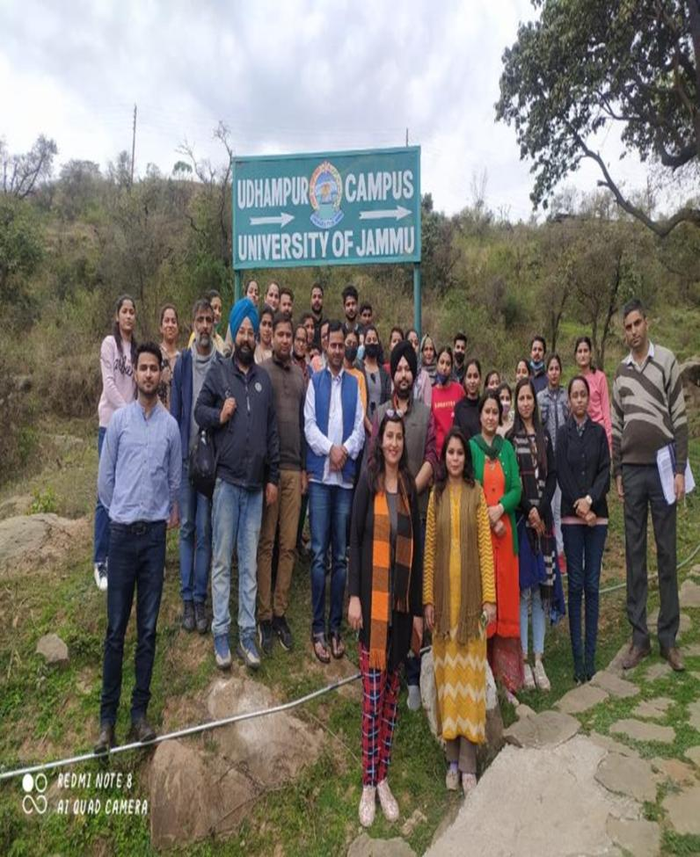

2. Online Webinar On Stock Market Trading In Collaboration With UNIVERSITY BUSINESS INCUBATION AND INNOVATION CENTRE Under Udhampur Campus Capacity Building Series (UCCBS)

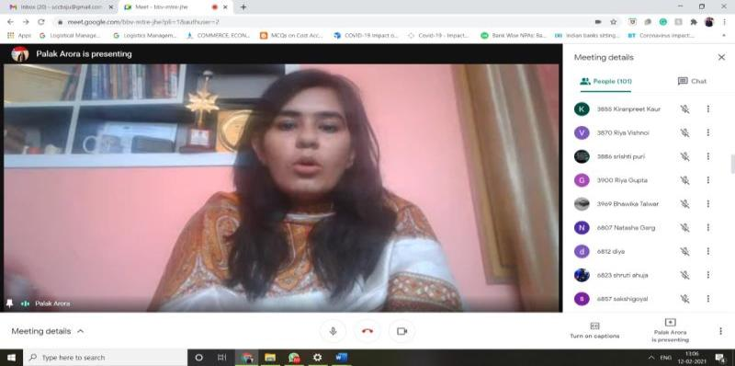

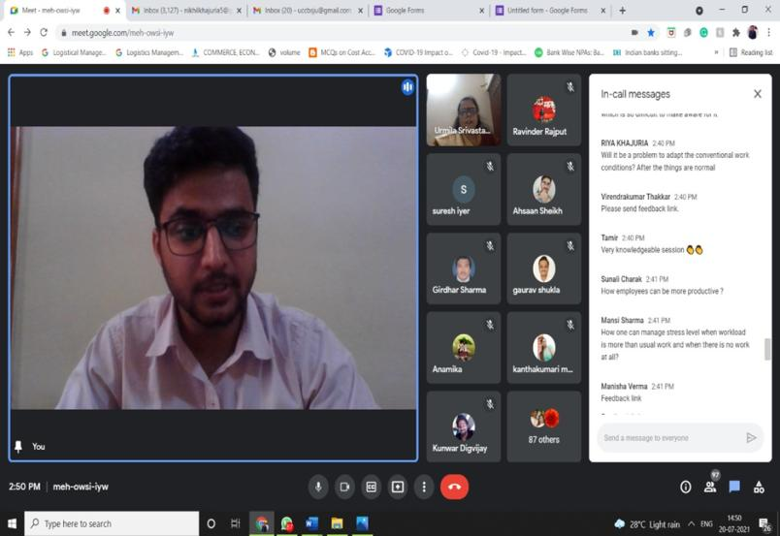

3. INAUGURATION OF UDHAMPUR CAMPUS FACILITATION CENTRE- FINANCIAL LITERACY CAMPAIGN IN COLLABORATION WITH UNIVERSITY OF JAMMU SPECIAL PURPOSE VEHICLE FOUNDATION
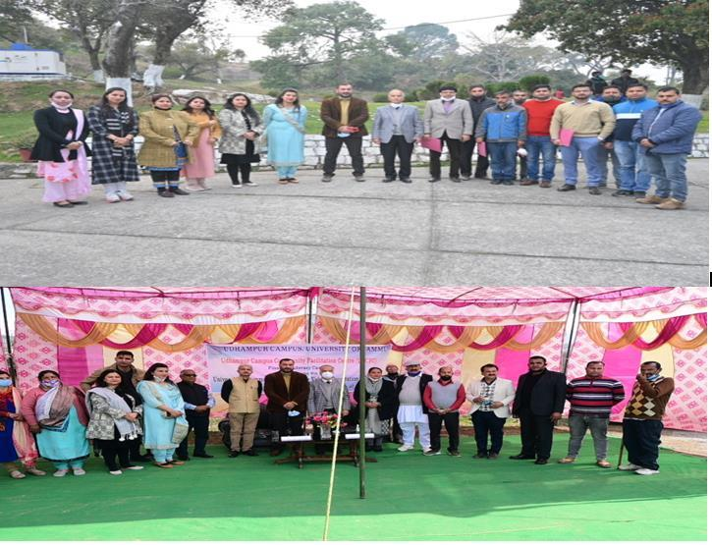

4. Webinar On Deconstruction Of An Advertisement Organized By Udhampur Campus In Collaboration With University Of Jammu In Special Purpose Vehicle Foundation

